Course Project Documentation

BE Final Year Project

**Bipedal Robot**

TEAM: 17

Tanmay Kavathekar

**Table of Contents**

1. Introduction..................................................................................1

2. Problem Statement......................................................................2

3. Requirements………………………………………………………...3

4. Implementation............................................................................4

5. Testing Strategy and Data...........................................................6

6. Discussion of System..................................................................8

7. Future Work.................................................................................9

8. Conclusion...................................................................................10

9. References..................................................................................11

**1. Introduction:**

Research in the area of robotics started in the 20th century and has resulted in robots of various types, many being a permanent part of today's industry. These robots perform the jobs that are physically demanding, monotonous or even hazardous to human beings. Also, they increase the work rate and the quality of products in places where factors such as speed and accuracy are essential. Today, robots are found in almost all modern assembly production lines.

Usually, these robots use a small set of fixed movement patterns which limits their possible interactions with the surroundings. Also, they are seldom in contact with humans. Research concerning robots capable of functioning in normal human surroundings and interacting with the human environment is still at an early stage. A part of this research area includes the development of robots using bipedal locomotion, i.e. walking on two legs, as these robots could function and perform tasks in a human environment without adjusting the surroundings to them. Robots using bipedal locomotion are called biped robots, and are often found within the class of robots known as humanoid robots.

**2. Problem Statement:**

The aim of the project is to design an autonomous robot which has a structure similar to human legs. The robot will have 6 DOF (Degree Of Freedom), 3 for each leg.

We also learn the concept of centre of gravity (CG) and how it the concept is applied by the human body to maintain stability while walking.

At the same time we learn the different phases through which the limbs undergo to create a smooth walking motion.

We use servo motors to build the robot as it will give more accuracy and control to create a smooth motion. Also controlling servo motor is easier than dc or stepper motors.

The controller to be used in the project should have more timers to generate PWM signals which are use to contol the motors.

**3. Requirements:**

**A) Hardware Requirements:**

1. Microcontroller: Atmega 640(Development board).
2. Motors: 6 Servo motors (NRS-785).
3. Servo jackets kits: 6 kits to hold the motors.
4. Servo arm kits: 8 kits to link the motors together.
5. Acrylic sheet: It is required to connect the two legs and as feet.

**B) Software Requirements:**

1. AVR studio: It is used to write, compile and debug the program.
2. AVR bootloader: It is used to load the hex file into the controller.

**4. Implementation:**

**A) Working:**

1. We first write a program to generate PWM signals. The pulse width varies from 0.6 ms-2.2 ms for a range of 0-180 degrees. Since the timer is an up time the maximum value stored is for 180 degrees. Thus using the crystal frequency to calculate time period of 1 clock cycle the value for timer is reloaded is calculated.

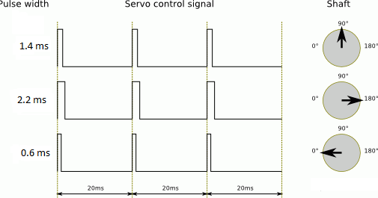

1. The servos are then tested and aligned at 90 degrees. After which robot is assembled using the servo arm and jacket kits and the servos are then interfaced to the microcontroller.
2. While choosing materials for the robot weight is a very important factor as it will determine the torque the motor has to supply to carry the weight. Hence we have used aluminium jackets and acrylic sheet as base.
3. While using servos the supply from the board is insufficient as each servo needs around 2 amperes for running, thus we have used a special supply of 15 amperes.
4. After which we program the robot the robot for various motions.

As the response of the servo is very quick we use a delay loop to slow down the servo.

1. The main task while programming is to maintain the CG (centre of gravity) on either of the legs at all times so that the robot is able to balance itself.

**B) Algorithm:**

Generally walking cycle consists of two steps namely Initialization and Walking.

**Initialization:**

In the Initialization step the robot will be in balanced condition and in this step the servomotors are made to return to home position.

**Walking:**

Walking step is further classified into six phases.

***Phase 1***– Double Support:

1. In this phase both the legs are in same line and the centre of mass is maintained between the two legs.

***Phase 2***– Single Support (Pre-Swing):

1. In this phase both the ankle joints are in actuated in roll orientation which shifts the centre of mass towards the left leg and the right leg will be lifted up from the ground.

***Phase 3***– Single Support (Swing):

1. In this phase, the right leg is lifted further and made to swing in the air. Hip and knee joints are actuated in pitch orientation so that right leg is moved forward.

***Phase 4***– Post Swing:

1. In this phase the lifted leg is placed down with the actuation of ankle joints.

***Phase 5***and ***6***

1. They are the mirror image of Phase 2 and Phase 3. After Phase 6, motion continues

**5. Testing Strategy and Data:**

**Motor testing:**

1. First, each motor of the robot is tested for proper functioning. Then the motor are aligned at 90 degrees. When the robot is assembled each servo is aligned at 45 and 135 degrees to check the direction of motion.

**Robot testing:**

1. We tried to tilt the robot on one leg, but it did not balance itself and toppled immediately. As a remedy we tilted the ankle servo so that the CG of the robot shifted slightly over the other leg, before tilting the robot over the other leg.

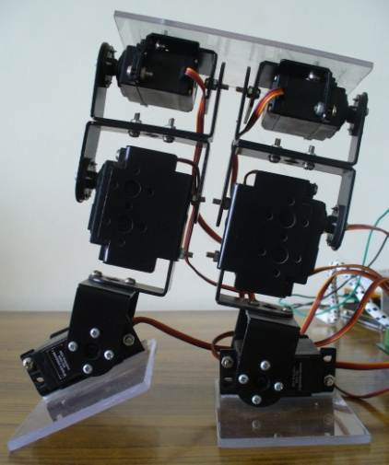

1. While tilting the robot over one leg we observed that the motion was too sudden, hence we introduced a “for” loop so that there was a delay after every 2 degree the motor moved.
2. Then we went forward create a sideways motion by tilting the ankle joint and pushing it suddenly to the ground. We get better motion if the surface is plain.
3. Then we move forward to perform a kicking motion. At this juncture we found that the supply used from the board was insufficient to drive more than 2 motors. Hence we used a supply of 5V,15A.
4. After kicking the next step was to complete the entire walking motion.
5. The following images show the working of the robot in the different phases of its walking algorithm.

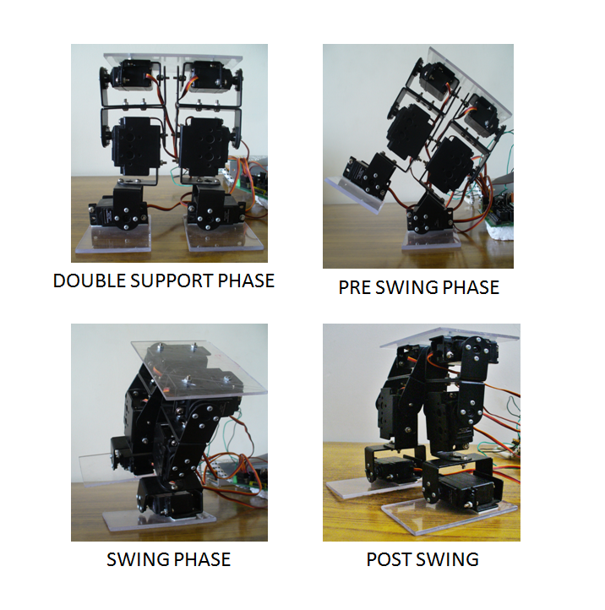

**6. Discussion of System:**

**A) What are worked as per plan?**

1. Construction of the robot:

The robot was constructed with the motors perfectly aligned at 90 degrees. Also the robot is very light in weight due to the servo arm and jackets are made of aluminium.

1. Efficiency of walking algorithm:

The algorithm was efficiently able to divide the walking motion into various phases making it easier to program the robot

1. Motion Control:

The various motion of the robot like sideways motion, kicking motion and walking motion were programmed and executed accurately.

**C) Changes made in plan:**

There hardly changes made in the plan as the things went as per the plans and what we had envisioned.

**7. Future Work:**

1. In our current implementation, we have used a development board to control the robot later a separate circuit can be made and mounted on the robot.
2. The upper body can be added to the biped to make a humanoid robot.
3. We can have force sensors and gyro sensor used to help robot take independent decisions and I/R sensors to detect obstacles.

**8. Conclusions:**

The Bipedal Robot has many uses and future applications. It introduces uses to the challenges faced to build humanoid robots. It also highlights that fact that the human body is really complex machine whose intricate workings have always baffled us and mimicking them is very difficult. These robots will be a boon to the quadriplegic people and replacement to humans in dangerous environment.

**9. References:**

1. **Bipedal Robots** by Christine C., Guy B., Gabriel A. & Yannick A.
2. **ASIMO** -http://asimo.honda.com/education-materials/
3. T. Ishida, Y. Kuroki and T. Takahashi, *‘Analysis of Motion of a small Biped Entertainment Robot’*, Proc. IEEE/RSJ International Conference on Intelligent Robots and Systems, p144-p147, 2004
4. Q. Li, A. Takanishi and I. Kato, *‘A Biped Walking Robot Having a ZMP Measurement System Using Universal Force-Moment Sensors’*, Proc. IEEE/RSJ International Workshop on Intelligent Robots and Systems, 1991.
5. Wolff, K., and Nordin, P., *‘Evolutionary Learning from First Principles of Biped Walking on a Simulated Humanoid Robot’,* The Advanced Simulation Technologies Conference 2003 ASTC'03.
6. Jong-Hwan Kim, Kui-Hong Park, Jun-Su Jang, Yong-Duk Kim, Bum-Joo Lee and Ki-PyoKim, *‘Humanoid Robot HanSaRam: Schemes for ZMP compensation’*, Proc. Of International Conference on Computational Intelligence, Robotics and Autonomous Systems, Singapore, 2003.
7. ATMEGA 640 data sheet
8. ATMEGA 640 development board manual
9. nex-robotics.com